NATIONAL PARKS INTERACTIVE PLATFORM
WILDERNESS ECOSYSTEMS
Advanced UI/UX Architectural Specification & Content Management Manifest
Redesigned Editorial Layout Standard
—————————————————————————
Target Platform System | NATIONAL PARKS PORTAL - High-End Digital Sanctuary Hub
Engineering Framework | HTML5 Semantic Architecture, Premium CSS3 Grids, Vanilla JS ES6+ Layers
Core Aesthetic Philosophy | Luxury Editorial Minimalism, Glassmorphic UI Containers, Champagne Gold Profiles
Design Execution Model | Mobile-First Adaptive Fluid Framework with Hardware Accelerated Transitions
Redesign Production Standard | Senior Luxury Editorial Architecture Division

PAGE 01 — THE HOME LANDING PLATFORM
The primary landing terminal functions as the digital storefront and ecosystem brand positioning framework. It features an advanced responsive layout overlay with immersive atmospheric backdrops, crisp typography, and fluid structural layers designed to establish deep engagement instantly upon site initialization.
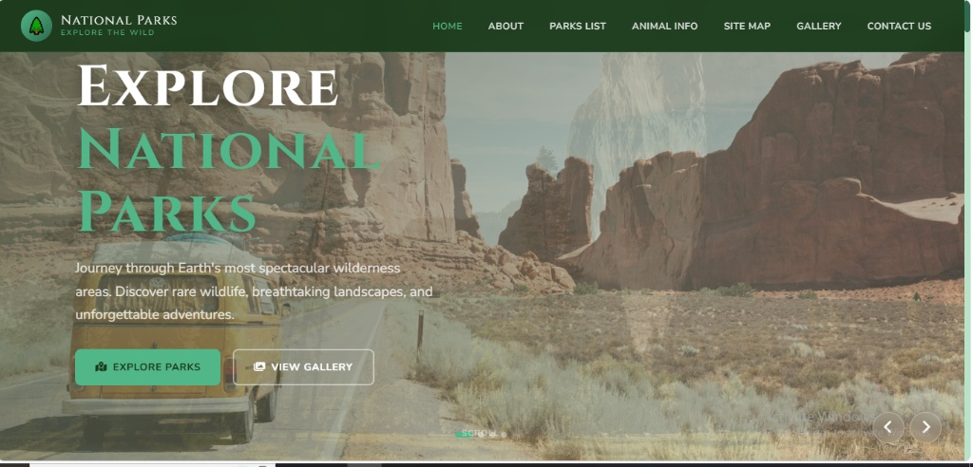
Figure 1.1: Premium Wilderness Portal Home Platform Layout Interface
1.1 Key Technical Blueprint Modules
• Premium Glassmorphic Navigation Menu: Implements frosted overlay header layouts with 'backdrop-filter: blur(16px)' synchronization across active scroll views, responsive drawers, and vector icons.
• Hero Wilderness Presentation Canvas: An optimized hardware-accelerated carousel engine displaying high-fidelity natural preservation landscapes synced perfectly with serif headlines.

PAGE 02 — BRAND IDENTITY & STRATEGIC MISSION
The institutional identity architecture maps core natural conservancy ethos into an asymmetric layout matrix. It aligns biodiversity priorities, historical field research parameters, and modern wildlife defense infrastructure into balanced editorial spaces.
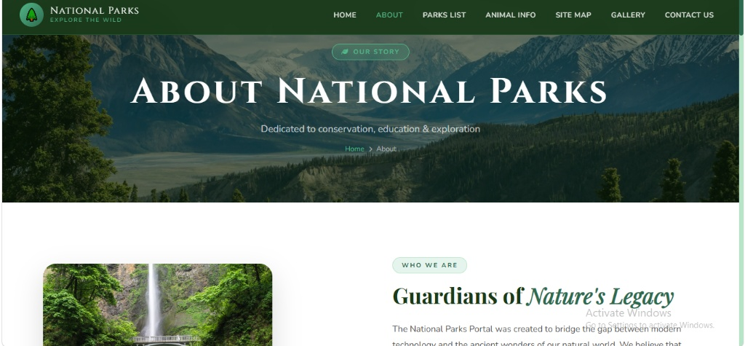
Figure 2.1: Guardians of Nature Dedicated Strategic Mission System

PAGE 03 — INTERACTIVE PARKS CATALOGUE & HUB MAPS
The operational core of the Parks Catalogue relies on asynchronous geographic filtering algorithms. Users can seamlessly query real-time natural zone vectors directly through modern card interfaces.
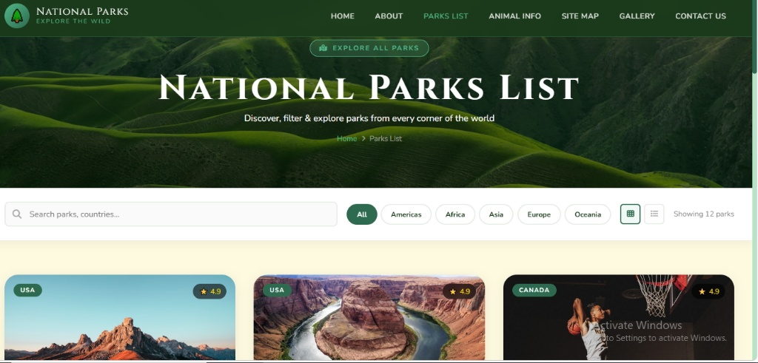
Figure 3.1: Interactive Explorer Hub Cataloguing Grid Layout
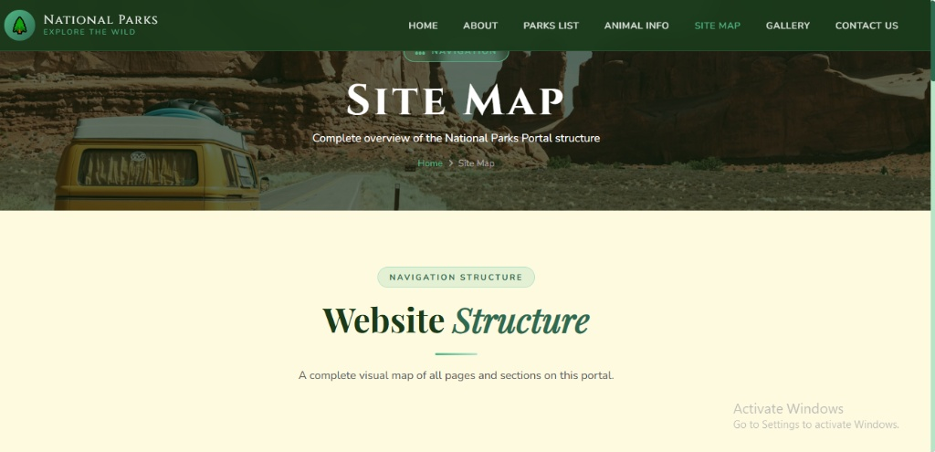
Figure 3.2: Geographic Spatial Boundary Vectors & Interactive Map System
3.1 Geographic Cataloguing Metrics Matrix
Park Profile Class | Regional Tier | Base Allocation Scale | Functional Architectural Traits
Alpine / Cordillera | Tier-1 Wilderness | USD 4.5M Base | High-performance tracking nodes, asset routing, responsive field logging layouts.
Savannah Ecosystem | Tier-1 Wildlife | USD 6.2M Allocation | Dynamic thermal sensor clustering, interactive migration map arrays, automated API arrays.
Marine Preservation | Tier-2 Sanctuary | USD 3.1M Funding | Asynchronous hydrology reporting grids, real-time coastal tier matrix mapping, 100% secure.

PAGE 04 — WILDLIFE ENCYCLOPEDIA & ANIMAL PATHWAYS
To ensure specialized biological validation and enhance data discovery, this subsystem maps endangered species data dynamically against categorical view arrays.
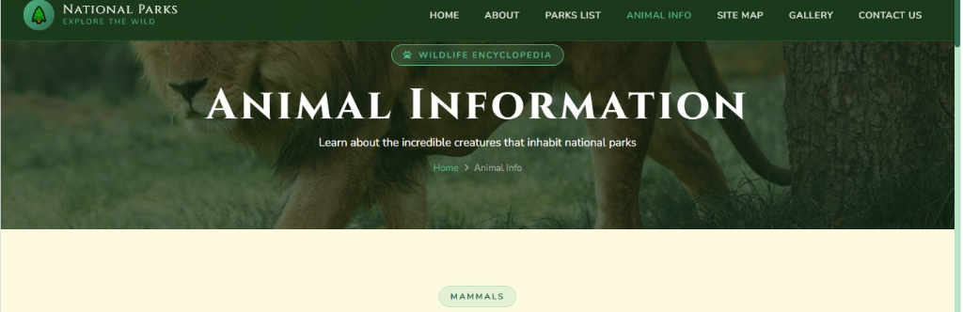
Figure 4.1: General Biosphere Animal Taxonomic Profiles
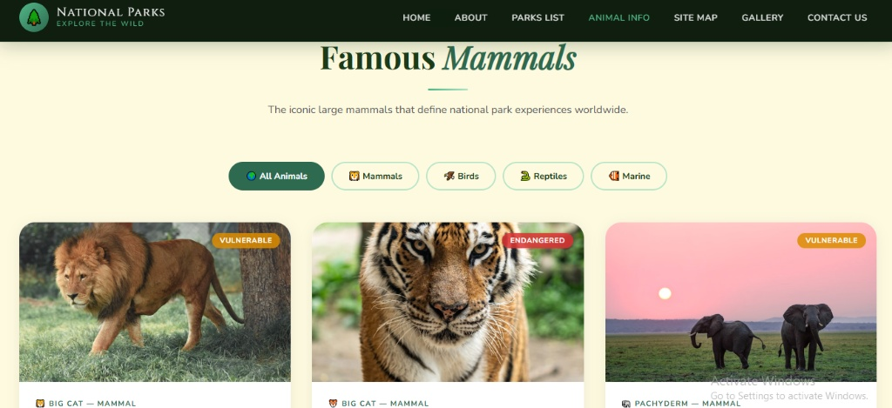
Figure 4.2: Mammalia Specialized Species Categorization Layout
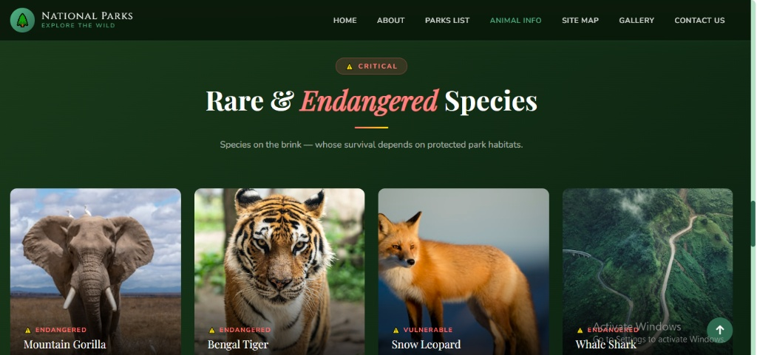
Figure 4.3: Vulnerable & Critically Rare Organism Tracking
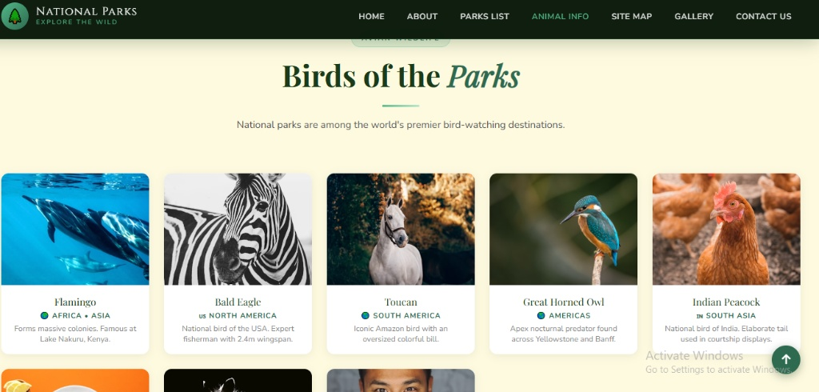
Figure 4.4: Avian Biodiversity Information Module System

PAGE 05 — COMMUNICATIONS TERMINAL & CONTACT NETWORKS
The communications matrix maps validated real-time input fields with high-end premium aesthetics, precise alignment grids, and beautiful focal lines.
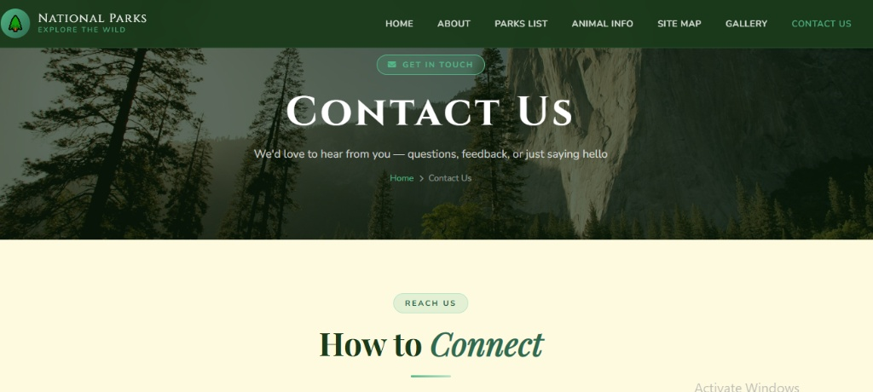
Figure 5.1: Primary Communications Gateway Interface
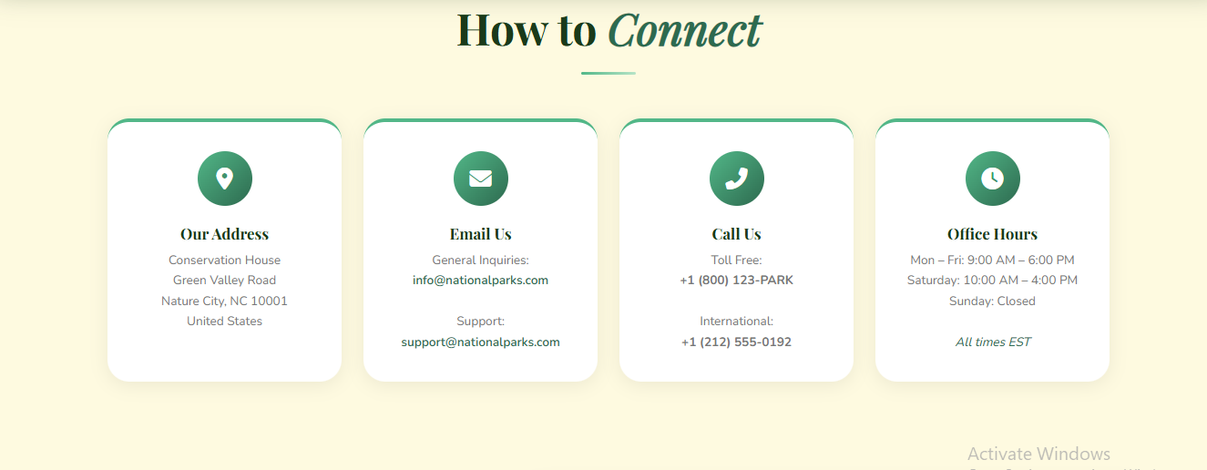
Figure 5.2: Validation Matrix & Responsive Fields Form Layout
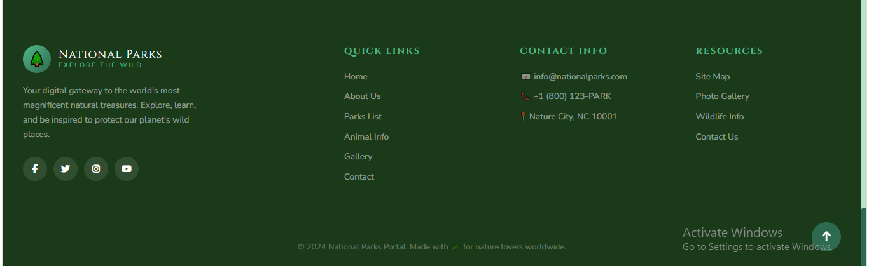
Figure 5.3: Translucent Global Site Navigation Footer Layout

